|  |  |  |
| --- | --- | --- |
| **Name** | **ID** | **STUDENT SIGN** |
| **Sumaiya Tasnim** | **23-50014-1** | **Sign** |

**Instructions:**

* **Make sure to write your Name, ID and Signature on this document.**
* **First write your signature on a paper then take photo of that signature and use it for signing this document.**
* **After completing the requirements of the midterm assignment by editing this document, upload this document in the link provided in your VUES Student Account.**
* **Submission Deadline: 18th August 2025, 11:59pm.**

**Midterm Assignment**

1. **Below a scenario has been given draw the ER Diagram.**

***Draw with proper annotations (use DIA, VISIO, MS WORD etc.).***

***For reference see ERDiagramTutorial.***

In a Juice Bar Management System, one Juice Bar may have many staff. But one staff can work in one Juice Bar only. Each staff has a unique identification number, name, age, address, date of birth and phone number. Juice Bar has a unique identification number, address, and phone. One Juice Bar maybe rented by exactly one owner. One owner may rent exactly one Juice Bar. Owner is defined by name, address, email and phone. A Juice Bar may have many customers. Each customer has a unique identification number, name, address, email, phone. Each customer can have more than one email address and phone number. A Juice Bar must pay the utility bill which has a unique identification number, payment_type and amount.

Answer Box 1: ( I have used “draw.io” as tool to create the ER diagram)

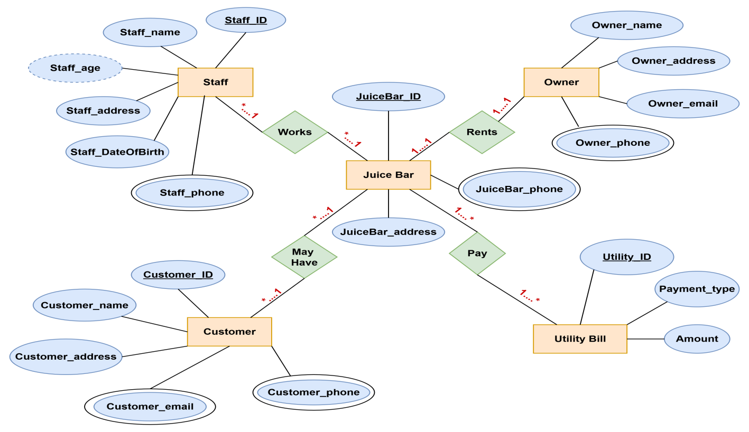

1. **Below an ER Diagram has been given write the scenario.**

***For reference see ERDiagramTutorial.***

Answer Box 2:

In a Bus Ticketing Management System, one **bus** is operated by exactly one **driver**, while one **driver** can operate only one **bus**. Each driver has a unique driver ID, name, license number, first name, last name, and years of experience. Each bus has a unique bus number and is defined by its type, model, and capacity. A **bus** follows exactly one **route**, and a **route** can be followed by buses. A **route** has a unique route ID and is defined by start location, end location, destination, distance, and departure time.Each **bus** is conducted by exactly one **supervisor**, and one supervisor can conduct only one bus. A **supervisor** is uniquely identified by supervisor ID and is described by name, first name, last name, and experience year. A **supervisor** issues many **tickets**, but each **ticket** is issued by only one supervisor. A **ticket** is assigned to exactly one bus and contains details such as ticket number, ticket price, ticket status, and seat number.A **ticket** is bought by one or more **passengers**, and each **passenger** can buy multiple **tickets**. Each passenger is uniquely identified by their national ID and is described by name, gender, phone number, first name, and last name.A **passenger** makes one or more **transactions**, and each transaction is made by one passenger only. A **transaction** is uniquely identified by a transaction ID and is described by date and ticket amount. Each transaction uses exactly one **payment type**, but a payment type can be used in many transactions. A **payment type** is defined by its payment code, method, and type.

1. **Normalize the ER Diagram given below up to 3rd Normal Form and finalize the tables that needs to be created. Then (in Oracle using SQL) write down the queries that are required to create all the tables with necessary constraints. Also insert at least 3 rows of data in each created table.**

***For reference see NormalizationTutorial and BasicSQLTutorial.***

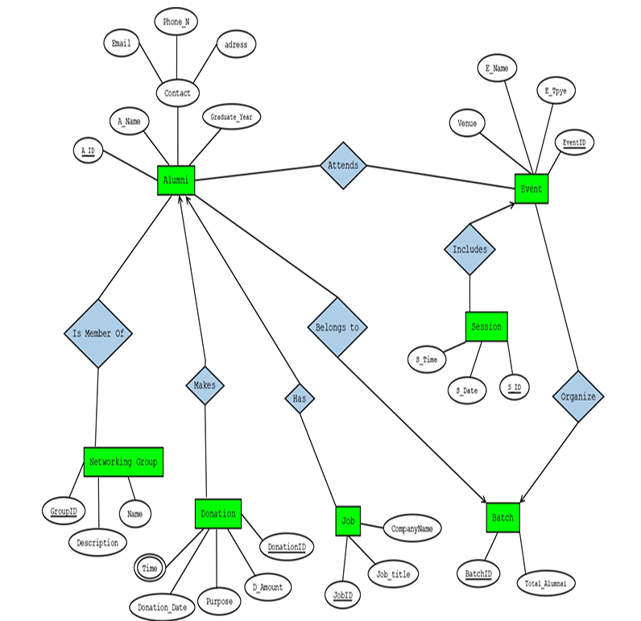

Answer Box 3 (Normalization steps in detail as shown in Normalization Tutorial Slide + all the queries required to create the tables and insert data after Normalization):

**Attends**

**UNF**

Alumni(A_ID ,A_name, Contact, address, Phone_N, Email, Graduate_Year, Venue, E_Name, E_Type, Event_ID )

**1NF**

There is no multi valued attribute. Relation is already in 1NF.

1. A_ID ,A_name, Contact, address, Phone_N, Email, Graduate_Year, Venue, E_Name, E_Type, Event_ID

**2NF**

1. A_ID ,A_name, Contact, address, Phone_N, Email, Graduate_Year
2. Venue, E_Name, E_Type, Event_ID

**3NF**

There is no transitive dependency. Relation already in 3NF.

1. A_ID ,A_name, Contact, address, Phone_N, Email, Graduate_Year
2. Venue, E_Name, E_Type, Event_ID

**Table Creation**

1. A_ID ,A_name, Contact, address, Phone_N, Email, Graduate_Year
2. Venue, E_Name, E_Type, Event_ID, **A_ID**

### ****Is Member Of****

**UNF**  
Alumni(A_ID, A_Name, Contact, Address, Phone_N, Email, Graduate_Year, GroupID, Group_Name, Group_Description)

**1NF**  
There is no multi-valued attribute. Relation is already in 1NF.

1. A_ID, A_Name, Contact, Address, Phone_N, Email, Graduate_Year, GroupID, Group_Name, Group_Description

**2NF**

1. A_ID, A_Name, Contact, Address, Phone_N, Email, Graduate_Year

2. GroupID, Group_Name, Group_Description

**3NF**  
There is no transitive dependency. Relation already in 3NF.

1. A_ID, A_Name, Contact, Address, Phone_N, Email, Graduate_Year

2. GroupID, Group_Name, Group_Description

**Table Creation**

1. A_ID, A_Name, Contact, Address, Phone_N, Email, Graduate_Year

2. GroupID, Group_Name, Group_Description, **A_ID**

### ****Makes****

**UNF**  
Alumni(A_ID, A_Name, Contact, Address, Phone_N, Email, Graduate_Year, DonationID, Donation_Date, Time, Purpose, D_Amount)

**1NF**  
Time is a multi valued attribute.

1. A_ID, A_Name, Contact, Address, Phone_N, Email, Graduate_Year, DonationID, Donation_Date, Time, Purpose, D_Amount

**2NF**

1. A_ID, A_Name, Contact, Address, Phone_N, Email, Graduate_Year

2. DonationID, Donation_Date, Time, Purpose, D_Amount

**3NF**  
There is no transitive dependency. Relation already in 3NF.

1. A_ID, A_Name, Contact, Address, Phone_N, Email, Graduate_Year
2. DonationID, Donation_Date, Time, Purpose, D_Amount

**Table Creation**

1. A_ID, A_Name, Contact, Address, Phone_N, Email, Graduate_Year

2. DonationID, Donation_Date, Time, Purpose, D_Amount, **A_ID**

### ****Has****

**UNF**  
Alumni(A_ID, A_Name, Contact, Address, Phone_N, Email, Graduate_Year, JobID, Job_Title, CompanyName)

**1NF**  
There is no multi-valued attribute. Relation is already in 1NF.

1. A_ID, A_Name, Contact, Address, Phone_N, Email, Graduate_Year, JobID, Job_Title, CompanyName

**2NF**

1. A_ID, A_Name, Contact, Address, Phone_N, Email, Graduate_Year
2. JobID, Job_Title, CompanyName

**3NF**  
There is no transitive dependency. Relation already in 3NF.

1. A_ID, A_Name, Contact, Address, Phone_N, Email, Graduate_Year
2. JobID, Job_Title, CompanyName

**Table Creation**

1. A_ID, A_Name, Contact, Address, Phone_N, Email, Graduate_Year
2. JobID, Job_Title, CompanyName, **A_ID**

### ****Belongs To****

**UNF**  
Alumni(A_ID, A_Name, Contact, Address, Phone_N, Email, Graduate_Year, BatchID, Total_Alumni)

**1NF**  
There is no multi-valued attribute. Relation is already in 1NF.

1.A_ID, A_Name, Contact, Address, Phone_N, Email, Graduate_Year, BatchID, Total_Alumni

**2NF**

1. A_ID, A_Name, Contact, Address, Phone_N, Email, Graduate_Year
2. BatchID, Total_Alumni

**3NF**  
There is no transitive dependency. Relation already in 3NF.

1. A_ID, A_Name, Contact, Address, Phone_N, Email, Graduate_Year
2. BatchID, Total_Alumni

**Table Creation**

1. A_ID, A_Name, Contact, Address, Phone_N, Email, Graduate_Year, BatchID
2. BatchID, Total_Alumni, **A_ID**

### ****Includes****

**UNF**  
Event(EventID, E_Name, E_Type, Venue, S_ID, S_Date, S_Time)

**1NF**  
There is no multi-valued attribute. Relation is already in 1NF.

1. EventID, E_Name, E_Type, Venue, S_ID, S_Date, S_Time

**2NF**

1. EventID, E_Name, E_Type, Venue
2. S_ID, S_Date, S_Time

**3NF**  
There is no transitive dependency. Relation already in 3NF.

1. EventID, E_Name, E_Type, Venue
2. S_ID, S_Date, S_Time

**Table Creation**

1. EventID, E_Name, E_Type, Venue
2. S_ID, S_Date, S_Time, **EventID**

### ****Organize****

**UNF**  
Event(EventID, E_Name, E_Type, Venue, BatchID, Total_Alumni)

**1NF**  
There is no multi-valued attribute. Relation is already in 1NF.

1. EventID, E_Name, E_Type, Venue, BatchID, Total_Alumni

**2NF**

1. EventID, E_Name, E_Type, Venue
2. BatchID, Total_Alumni

**3NF**  
There is no transitive dependency. Relation already in 3NF.

1. EventID, E_Name, E_Type, Venue
2. BatchID, Total_Alumni

**Table Creation**

1. EventID, E_Name, E_Type, Venue
2. BatchID, Total_Alumni, **EventID**

**Temporary Tables**

1. A_ID ,A_name, Contact, address, Phone_N, Email, Graduate_Year

2. Venue, E_Name, E_Type, Event_ID, **A_ID**

~~3. A_ID, A_Name, Contact, Address, Phone_N, Email, Graduate_Year~~

4. GroupID, Group_Name, Group_Description, **A_ID**

~~5. A_ID, A_Name, Contact, Address, Phone_N, Email, Graduate_Year~~

6. DonationID, Donation_Date, Time, Purpose, D_Amount, **A_ID**

~~7. A_ID, A_Name, Contact, Address, Phone_N, Email, Graduate_Year~~

8. JobID, Job_Title, CompanyName, **A_ID**

9. ~~A_ID, A_Name, Contact, Address, Phone_N, Email, Graduate_Year, BatchID~~

10. BatchID, Total_Alumni, **A_ID**

~~11. EventID, E_Name, E_Type, Venue~~

12. S_ID, S_Date, S_Time, **EventID**

~~13. EventID, E_Name, E_Type, Venue~~

~~14.BatchID, Total_Alumni,~~ **~~EventID~~**

**Final Tables**

1. A_ID ,A_name, Contact, address, Phone_N, Email, Graduate_Year
2. Venue, E_Name, E_Type, Event_ID, **A_ID**
3. GroupID, Group_Name, Group_Description, **A_ID**

4. DonationID, Donation_Date, Time, Purpose, D_Amount, **A_ID**

5. JobID, Job_Title, CompanyName, **A_ID**

6. BatchID, Total_Alumni, **A_ID**

7. S_ID, S_Date, S_Time, **EventID**

**(In Oracle using SQL) writing the queries below that are required to create all the tables with necessary constraints :**

**-- 1. Alumni Table**

CREATE TABLE Alumni (

A_ID NUMBER PRIMARY KEY,

A_name VARCHAR2(100) NOT NULL,

Contact VARCHAR2(50),

Address VARCHAR2(200),

Phone_N VARCHAR2(15) UNIQUE,

Email VARCHAR2(100) UNIQUE,

Graduate_Year NUMBER(4) );

**-- 2. Event Table**

CREATE TABLE Event (

Event_ID NUMBER PRIMARY KEY,

Venue VARCHAR2(100),

E_Name VARCHAR2(100),

E_Type VARCHAR2(50),

A_ID NUMBER,

FOREIGN KEY (A_ID) REFERENCES Alumni(A_ID)

);

**-- 3. Networking Group Table**

CREATE TABLE Networking_Group (

GroupID NUMBER PRIMARY KEY,

Group_Name VARCHAR2(100),

Group_Description VARCHAR2(200),

A_ID NUMBER,

FOREIGN KEY (A_ID) REFERENCES Alumni(A_ID)

);

**-- 4. Donation Table**

CREATE TABLE Donation (

DonationID NUMBER PRIMARY KEY,

Donation_Date DATE,

Time VARCHAR2(10),

Purpose VARCHAR2(200),

D_Amount NUMBER(10,2),

A_ID NUMBER,

FOREIGN KEY (A_ID) REFERENCES Alumni(A_ID)

);

**-- 5. Job Table**

CREATE TABLE Job (

JobID NUMBER PRIMARY KEY,

Job_Title VARCHAR2(100),

CompanyName VARCHAR2(100),

A_ID NUMBER,

FOREIGN KEY (A_ID) REFERENCES Alumni(A_ID)

);

**-- 6. Batch Table**

CREATE TABLE Batch (

BatchID NUMBER PRIMARY KEY,

Total_Alumni NUMBER,

A_ID NUMBER,

FOREIGN KEY (A_ID) REFERENCES Alumni(A_ID)

);

**-- 7. Session Table**

CREATE TABLE Event_Session (

S_ID NUMBER PRIMARY KEY,

S_Date DATE,

S_Time VARCHAR2(10),

EventID NUMBER,

FOREIGN KEY (EventID) REFERENCES Event(Event_ID)

);

**Inserting at least 3 rows of data in each created table:**

**-- Alumni**

INSERT INTO Alumni VALUES (1, 'John Smith', 'Facebook', 'NY, USA', '1234567890', 'john@example.com', 2015);

INSERT INTO Alumni VALUES (2, 'Sara Khan', 'Twitter', 'London, UK', '2345678901', 'sara@example.com', 2016);

INSERT INTO Alumni VALUES (3, 'David Lee', 'LinkedIn', 'Toronto, Canada', '3456789012', 'david@example.com', 2017);

**-- Event**

INSERT INTO Event VALUES (101, 'Auditorium', 'Alumni Meet', 'Social', 1);

INSERT INTO Event VALUES (102, 'Hall B', 'Career Fair', 'Professional', 2);

INSERT INTO Event VALUES (103, 'Conference Room', 'Workshop', 'Educational', 3);

**-- Networking Group**

INSERT INTO Networking_Group VALUES (201, 'Tech Group', 'Focus on IT networking', 1);

INSERT INTO Networking_Group VALUES (202, 'Business Leaders', 'Entrepreneurship and startups', 2);

INSERT INTO Networking_Group VALUES (203, 'Research Circle', 'Scientific research collaboration', 3);

**-- Donation**

INSERT INTO Donation VALUES (301, TO_DATE('2024-05-10','YYYY-MM-DD'), '10:00AM', 'Library Renovation', 5000, 1);

INSERT INTO Donation VALUES (302, TO_DATE('2024-06-15','YYYY-MM-DD'), '02:00PM', 'Scholarship Fund', 3000, 2);

INSERT INTO Donation VALUES (303, TO_DATE('2024-07-20','YYYY-MM-DD'), '11:00AM', 'Sports Complex', 7000, 3);

**-- Job**

INSERT INTO Job VALUES (401, 'Software Engineer', 'Google', 1);

INSERT INTO Job VALUES (402, 'Marketing Manager', 'Amazon', 2);

INSERT INTO Job VALUES (403, 'Data Scientist', 'Microsoft', 3);

**-- Batch**

INSERT INTO Batch VALUES (501, 150, 1);

INSERT INTO Batch VALUES (502, 200, 2);

INSERT INTO Batch VALUES (503, 180, 3);

**-- Session**

INSERT INTO Event_Session VALUES (601, TO_DATE('2024-08-01','YYYY-MM-DD'), '09:00AM', 101);

INSERT INTO Event_Session VALUES (602, TO_DATE('2024-08-05','YYYY-MM-DD'), '01:00PM', 102);

INSERT INTO Event_Session VALUES (603, TO_DATE('2024-08-10','YYYY-MM-DD'), '03:00PM', 103);

**4.Query Writing (continuation of Question 3) (Write down the question and the answer. Give full screenshot of the Oracle 10g Homepage that contains the answer and result)**

**-All screenshots MUST include the DATE and TIME feature from the screen of the machine (PC, Laptop etc.) used**

**SQL**

**-2 single-row function**

**-2 group function**

**-2 subquery**

**-2 joining**

***For reference see BasicSQLTutorial and AdvanceSQLTutorial.***

Answer Box 4:

**1. Single-Row Functions**

**Question(1): Display the names of alumni in uppercase and show their graduation year.  
Answer:**

SELECT UPPER(A_name) AS Alumni_Name, Graduate_Year FROM Alumni;

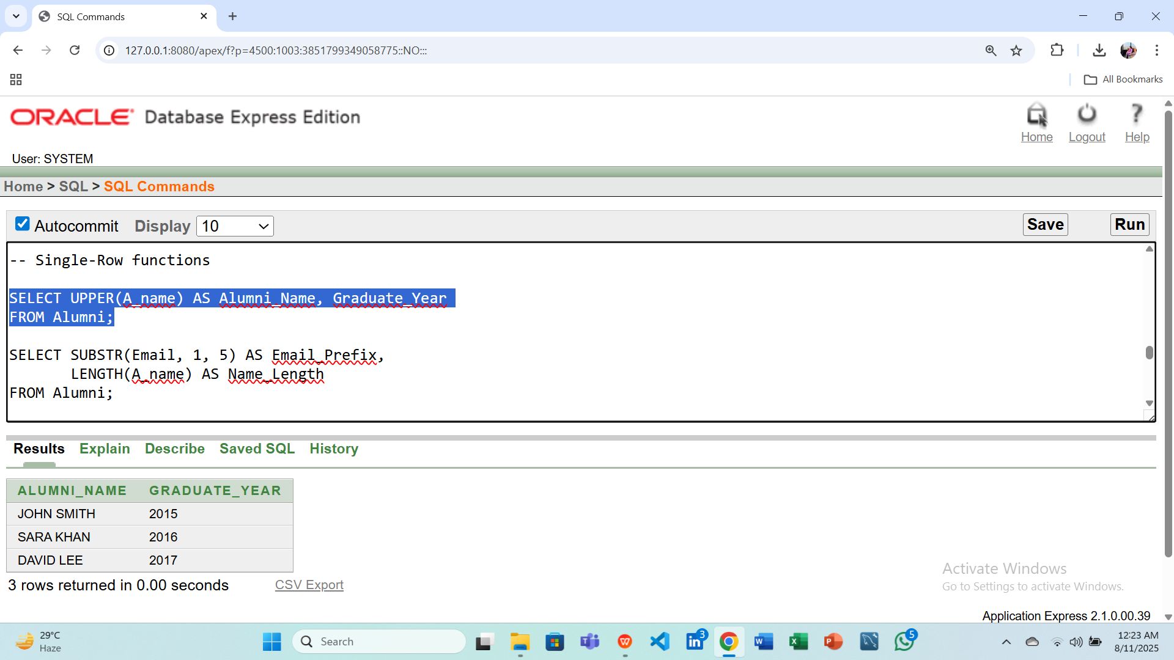

**Question(2): Display the first 5 characters of each alumni's email and the length of their name.  
Answer:**

SELECT SUBSTR(Email, 1, 5) AS Email_Prefix,

LENGTH(A_name) AS Name_LengthFROM Alumni;

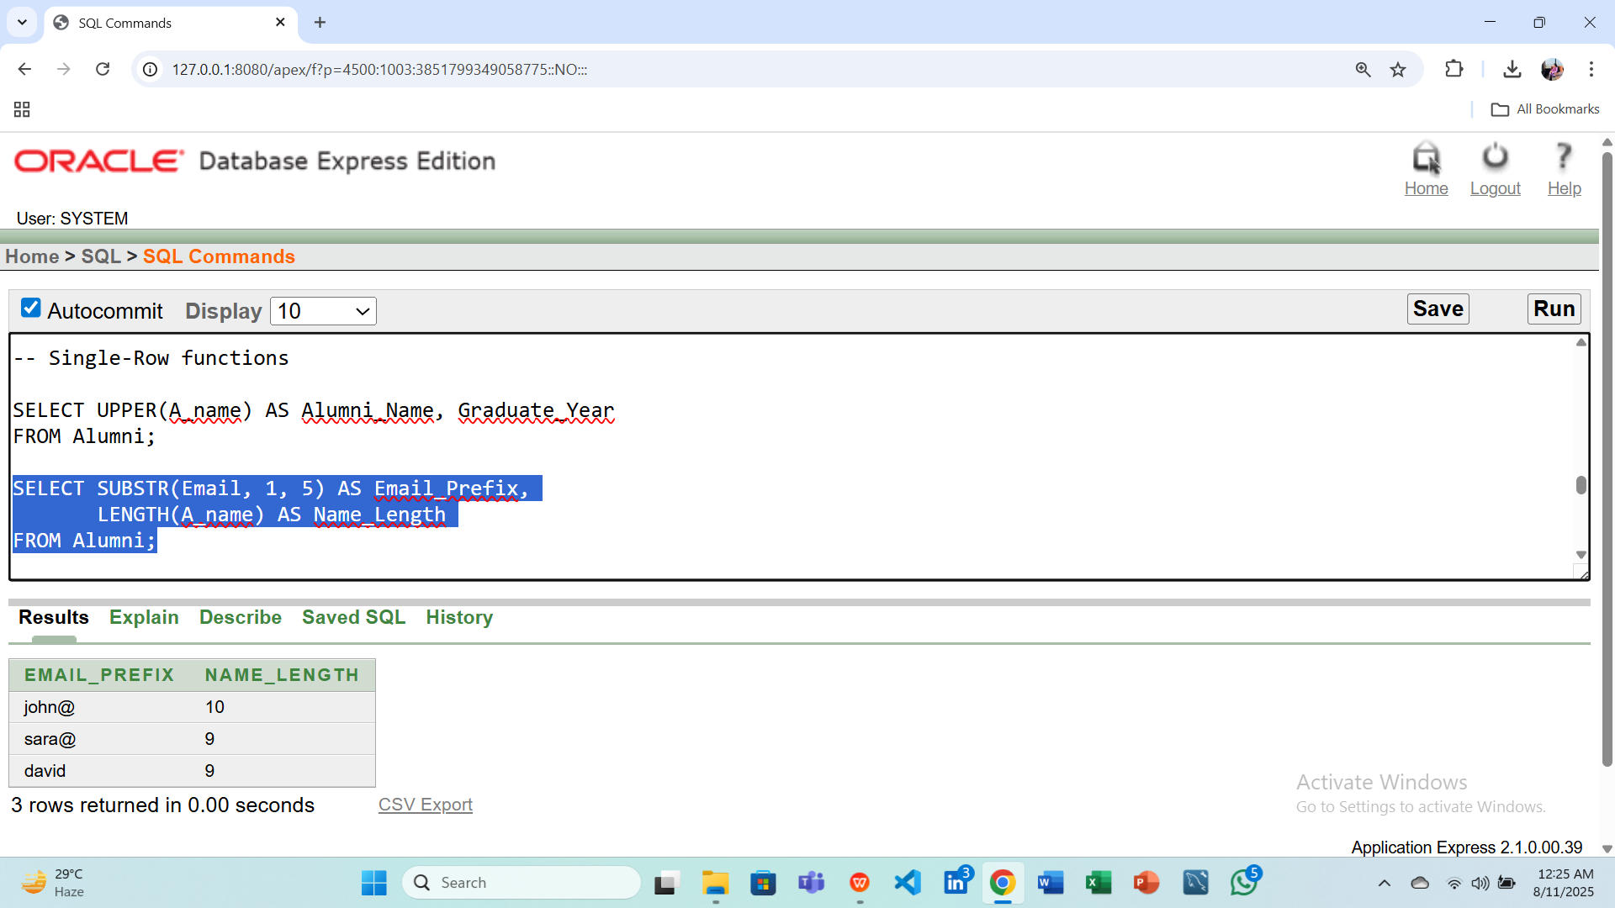

**2. Group Functions**

**Question(1): Find the total donation amount received from all alumni.  
Answer:**

SELECT SUM(D_Amount) AS Total_DonationsFROM Donation;

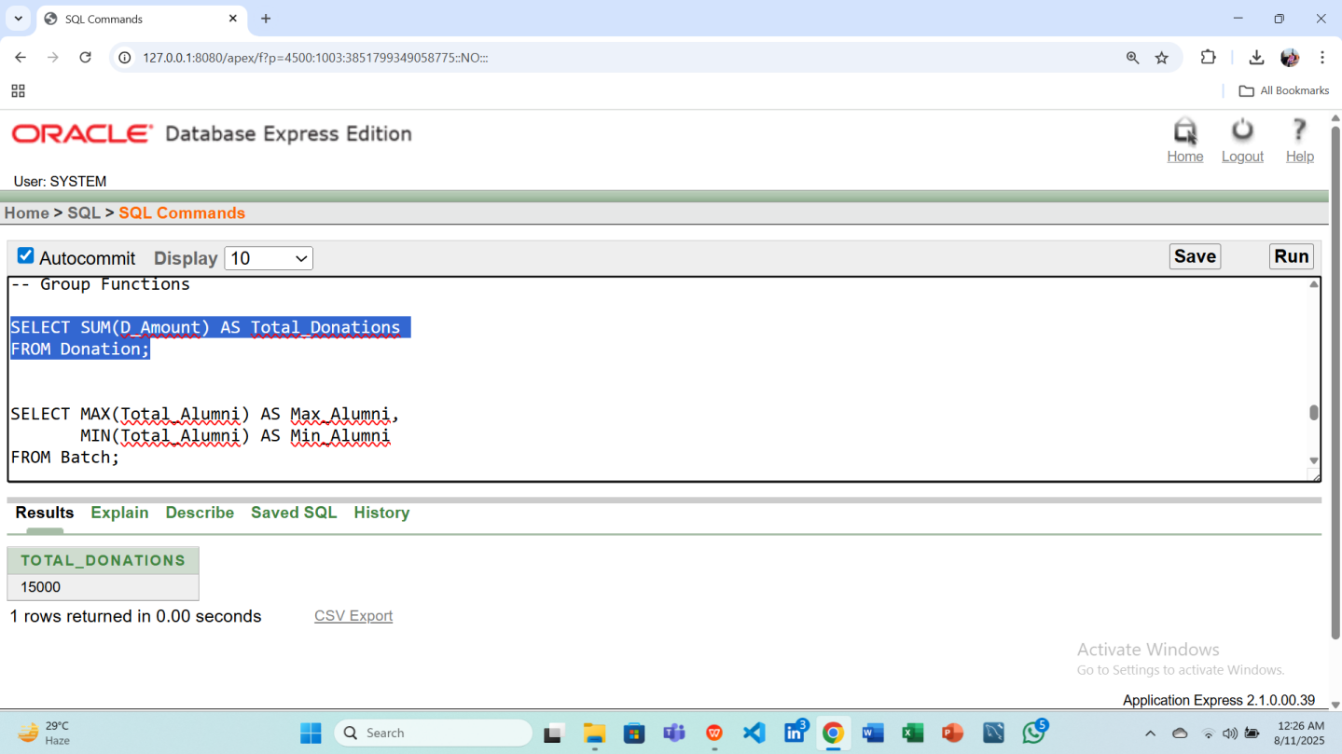

**Question(2): Find the maximum and minimum total alumni count among all batches.  
Answer:**

SELECT MAX(Total_Alumni) AS Max_Alumni,

MIN(Total_Alumni) AS Min_AlumniFROM Batch;

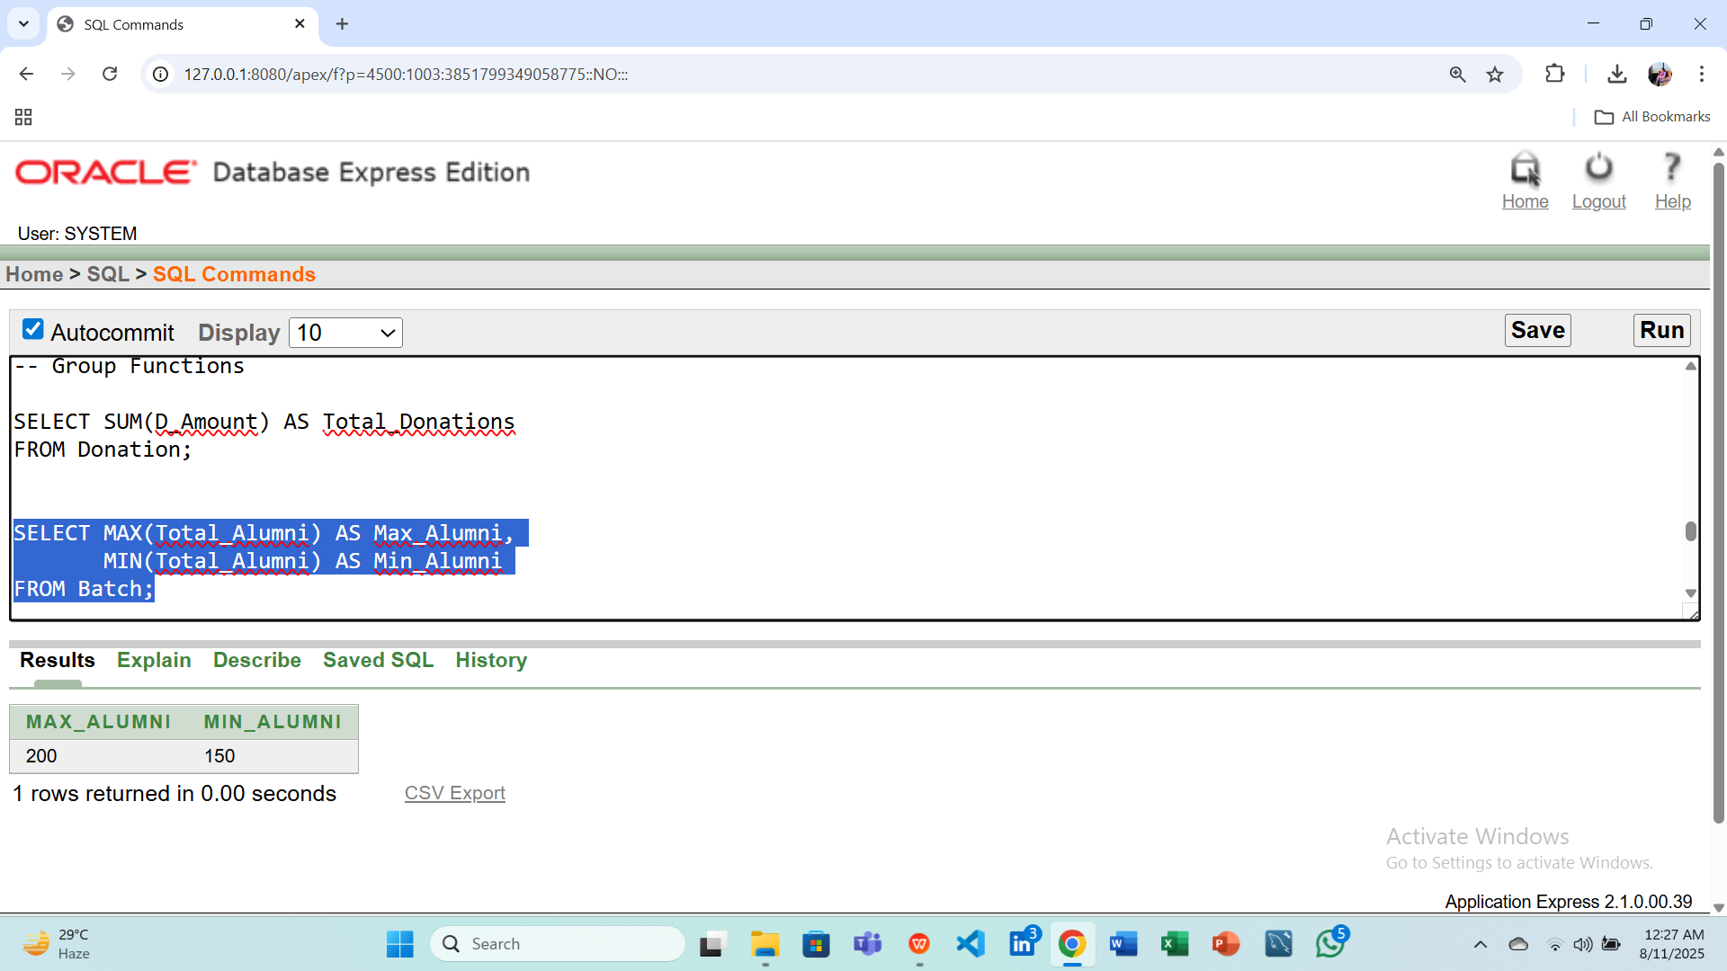

**3. Subqueries**

**Question(1): Display the alumni who donated more than the average donation amount.  
Answer:**

SELECT A_ID, Purpose, D_Amount

FROM Donation

WHERE D_Amount > (SELECT AVG(D_Amount) FROM Donation);

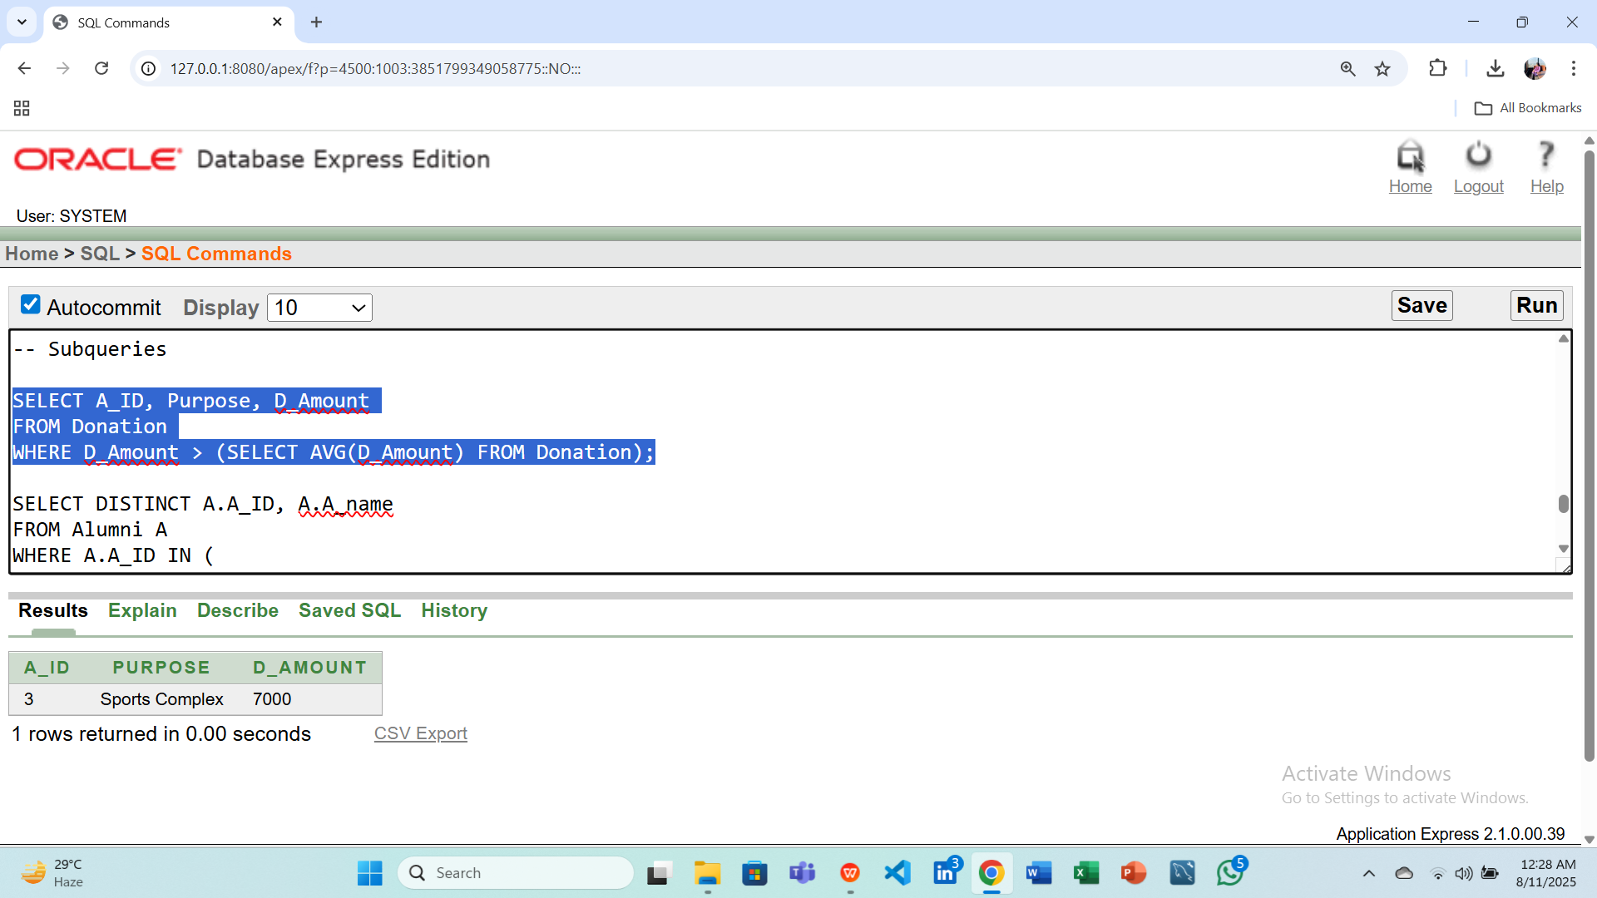

**Question(2): Display alumni who participated in events with the same venue as event ID 101.  
Answer:**

SELECT DISTINCT A.A_ID, A.A_nameFROM Alumni AWHERE A.A_ID IN (

SELECT A_ID

FROM Event

WHERE Venue = (SELECT Venue FROM Event WHERE Event_ID = 101)

);

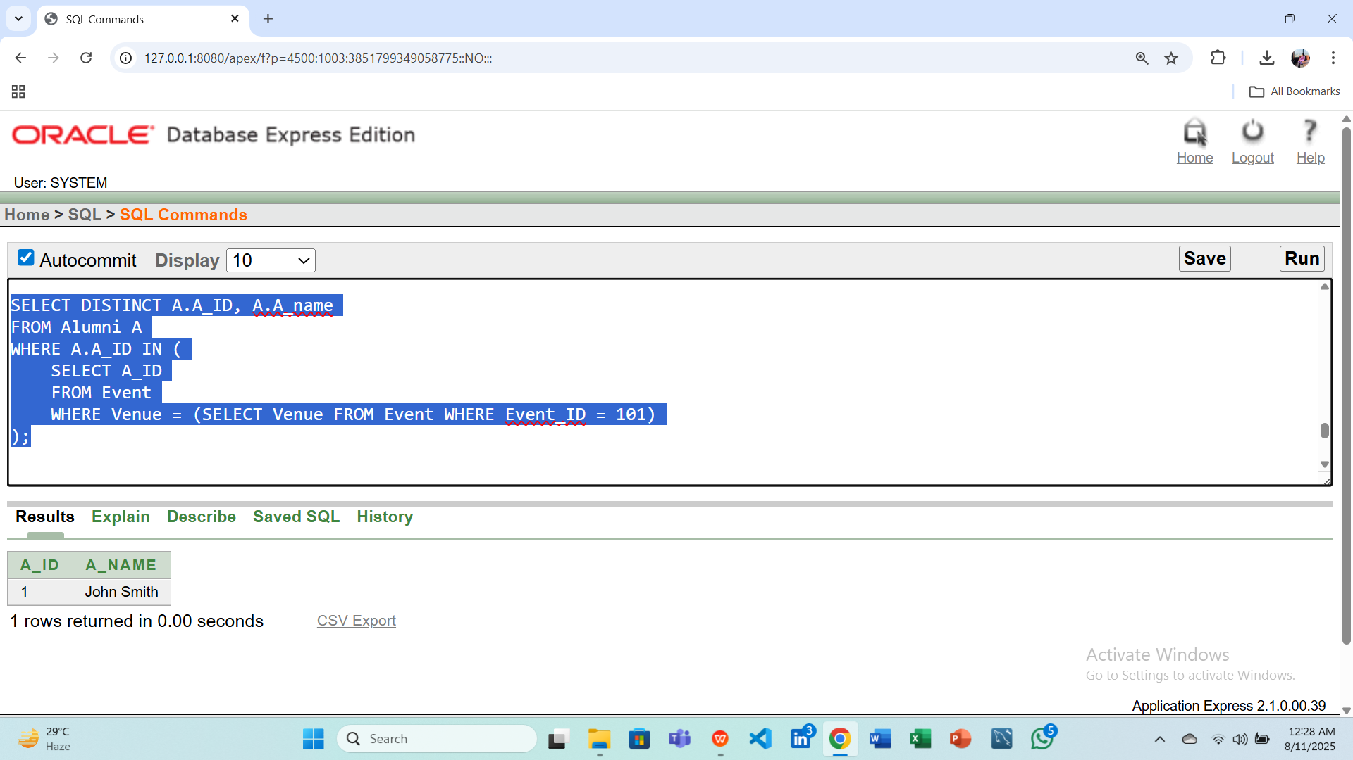

**4. Joins**

**Question(1): Display all alumni names along with the event names they are associated with.  
Answer:**

SELECT A.A_name, E.E_Name

FROM Alumni A

JOIN Event E ON A.A_ID = E.A_ID;

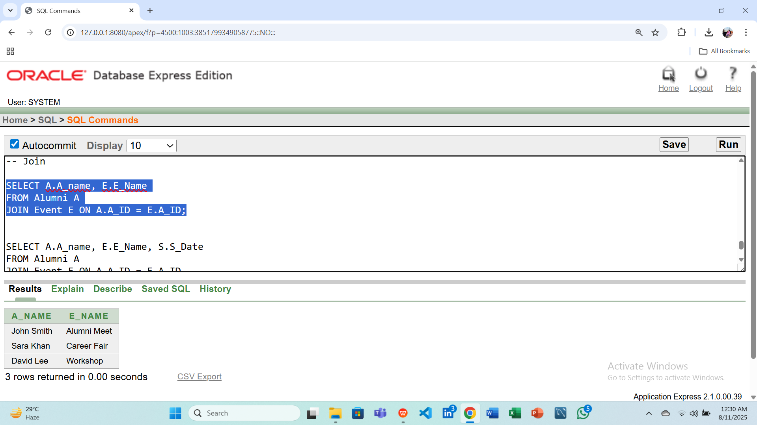

**Question(2): Display alumni names, event names, and session dates for all scheduled sessions.  
Answer:**

SELECT A.A_name, E.E_Name, S.S_Date

FROM Alumni A

JOIN Event E ON A.A_ID = E.A_ID

JOIN Event_Session S ON E.Event_ID = S.EventID;

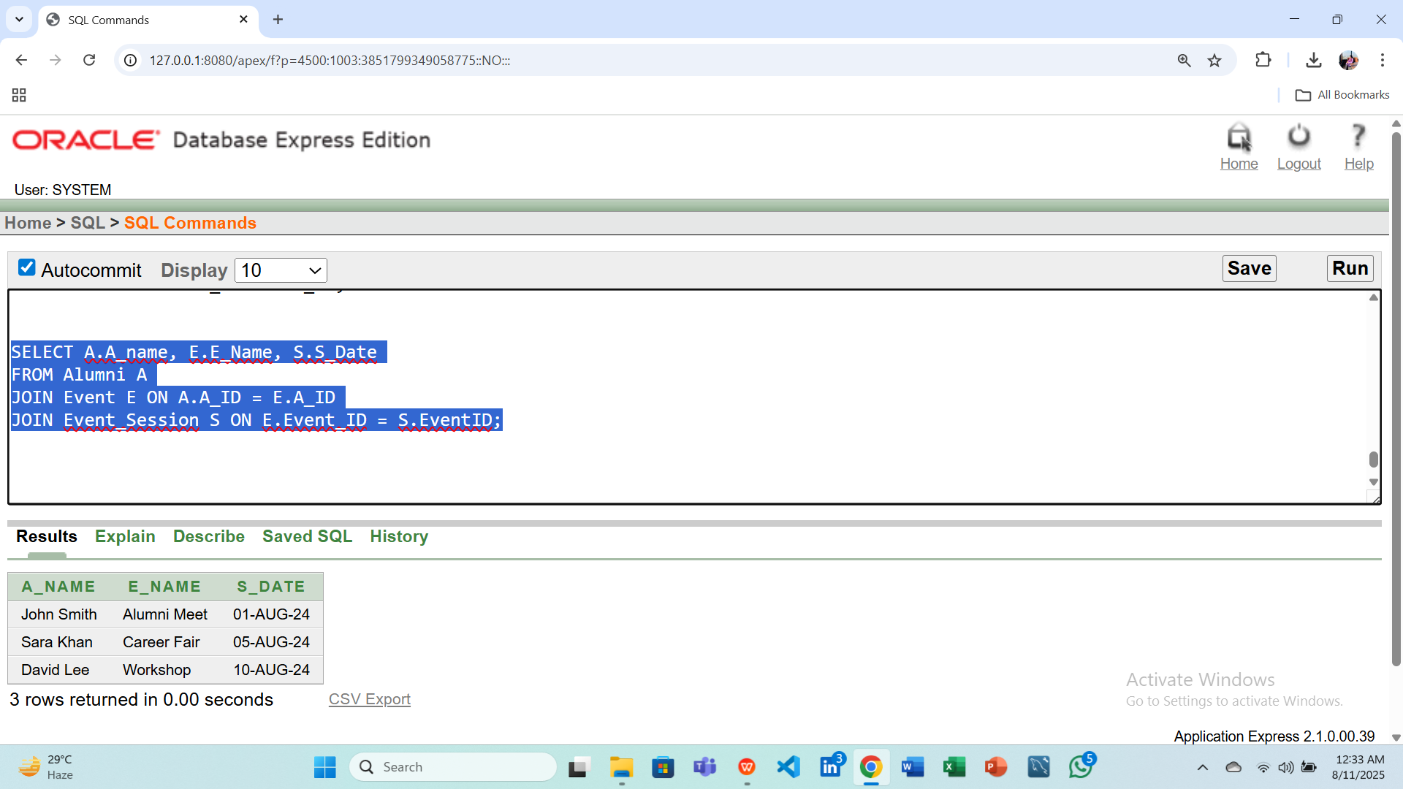

1. **Query Writing (continuation of Question 4) (Write down the answer only. Give full screenshot of the Oracle 10g Homepage that contains the answer and result)**

**-All screenshots MUST include the DATE and TIME feature from the screen of the machine (PC, Laptop etc.) used**

**PL/SQL**

1. **Convert the SQLs of Question 4 into equivalent PL/SQL code**
2. **For this part, 8 PL/SQL code must be submitted**

Answer Box 5:

**1. Single-Row Functions**

**Question(1): Display the names of alumni in uppercase and show their graduation year.  
Answer:**

BEGIN

FOR rec IN (

SELECT * FROM (

SELECT UPPER(A_name) AS Alumni_Name, Graduate_Year

FROM Alumni

ORDER BY A_name

)

WHERE ROWNUM <= 3

) LOOP

DBMS_OUTPUT.PUT_LINE('Name: ' || rec.Alumni_Name || ', Year: ' || rec.Graduate_Year);

END LOOP;

END;

/

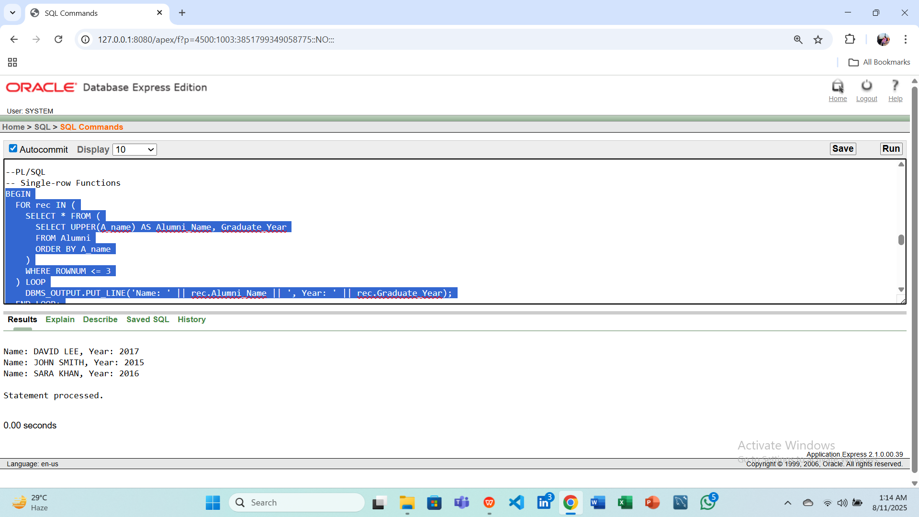

**Question(2): Display the first 5 characters of each alumni's email and the length of their name.  
Answer:**

BEGIN

FOR rec IN (

SELECT SUBSTR(Email, 1, 5) AS Email_Prefix,

LENGTH(A_name) AS Name_Length

FROM Alumni

) LOOP

DBMS_OUTPUT.PUT_LINE('Email Prefix: ' || rec.Email_Prefix || ', Name Length: ' || rec.Name_Length);

END LOOP;

END;

/

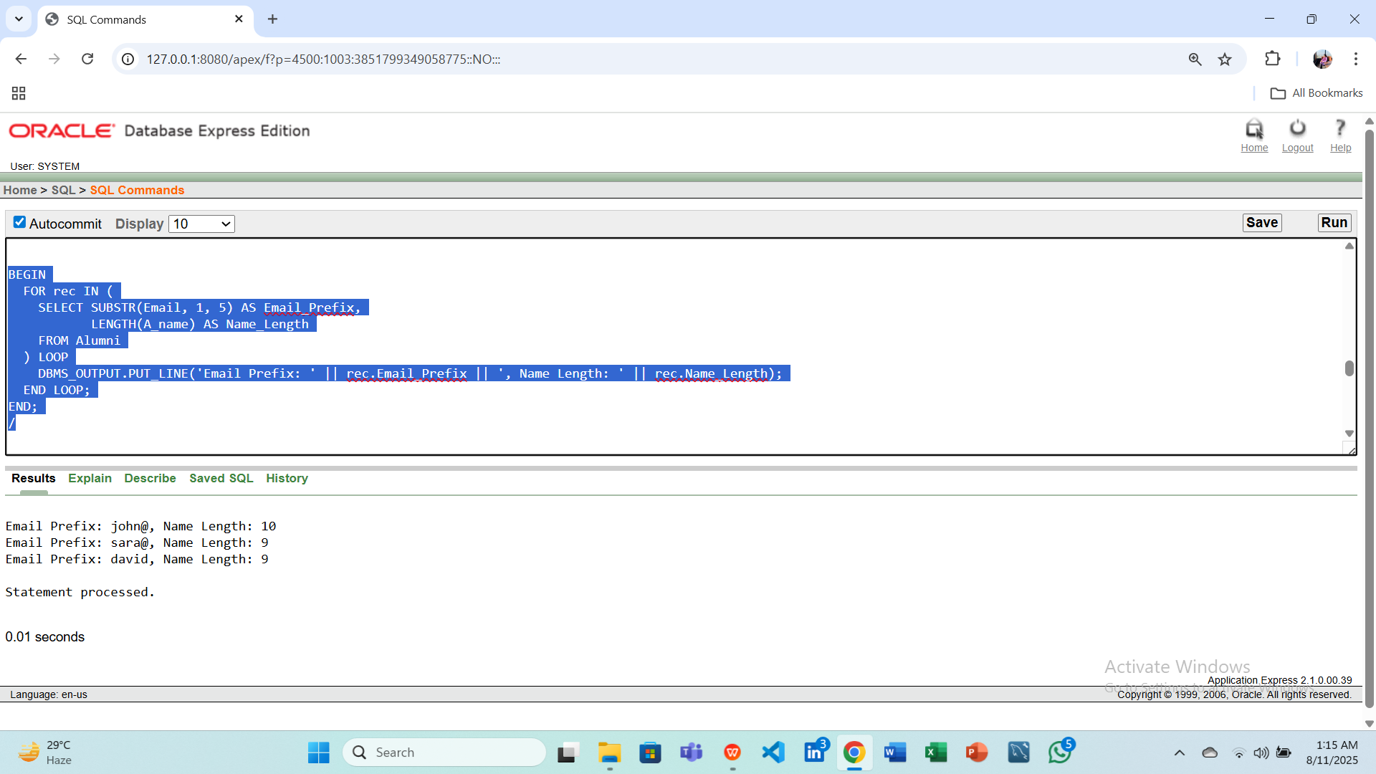

**2. Group Functions**

**Question(1): Find the total donation amount received from all alumni.  
Answer:**

DECLARE

v_total NUMBER;

BEGIN

SELECT SUM(D_Amount)

INTO v_total

FROM Donation;

DBMS_OUTPUT.PUT_LINE('Total Donations: ' || v_total);

END;

/

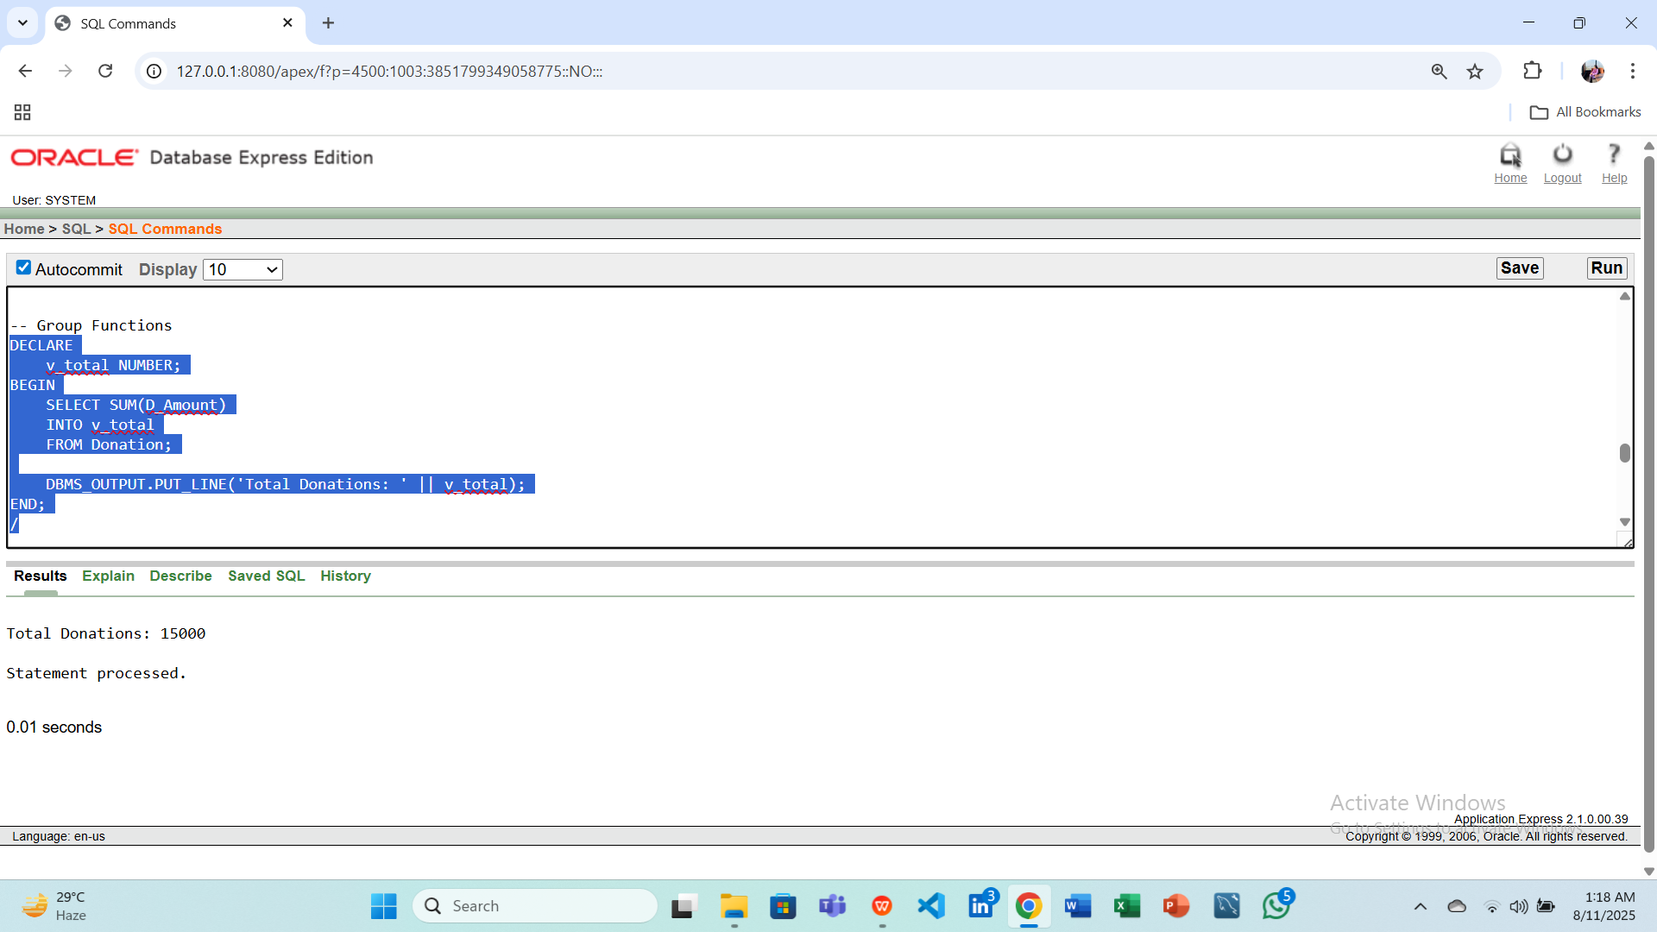

**Question(2): Find the maximum and minimum total alumni count among all batches.  
Answer:**

DECLARE

v_max NUMBER;

v_min NUMBER;

BEGIN

SELECT MAX(Total_Alumni), MIN(Total_Alumni)

INTO v_max, v_min

FROM Batch;

DBMS_OUTPUT.PUT_LINE('Max Alumni: ' || v_max || ', Min Alumni: ' || v_min);

END;

/

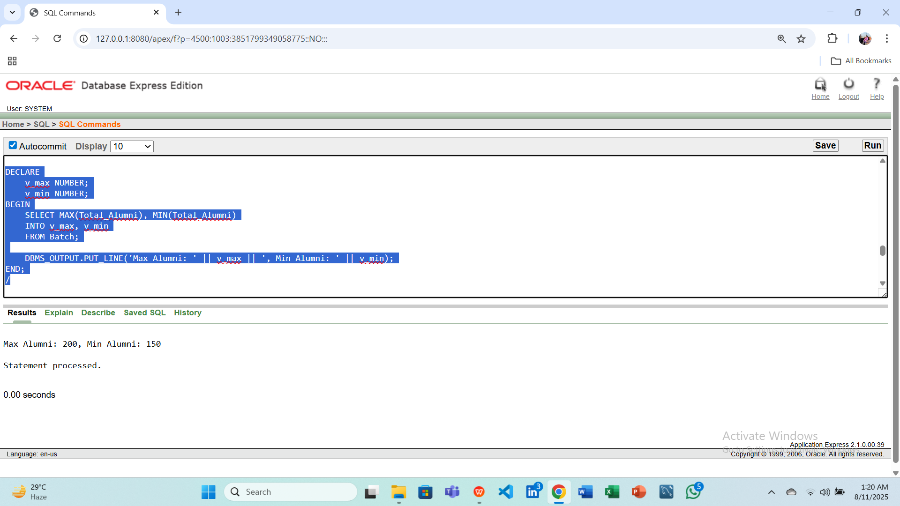

**3. Subqueries**

**Question(1): Display the alumni who donated more than the average donation amount.  
Answer:**

BEGIN

FOR rec IN (

SELECT A_ID, Purpose, D_Amount

FROM Donation

WHERE D_Amount > (SELECT AVG(D_Amount) FROM Donation)

) LOOP

DBMS_OUTPUT.PUT_LINE('A_ID: ' || rec.A_ID || ', Purpose: ' || rec.Purpose || ', Amount: ' || rec.D_Amount);

END LOOP;

END;

/

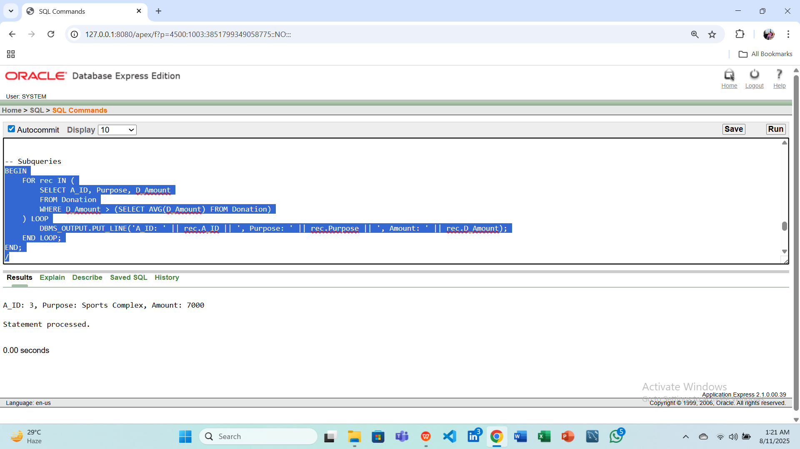

**Question(2): Display alumni who participated in events with the same venue as event ID 101.  
Answer:**

BEGIN

FOR rec IN (

SELECT DISTINCT A.A_ID, A.A_name

FROM Alumni A

WHERE A.A_ID IN (

SELECT A_ID

FROM Event

WHERE Venue = (SELECT Venue FROM Event WHERE Event_ID = 101)

)

) LOOP

DBMS_OUTPUT.PUT_LINE('A_ID: ' || rec.A_ID || ', Name: ' || rec.A_name);

END LOOP;

END;

/

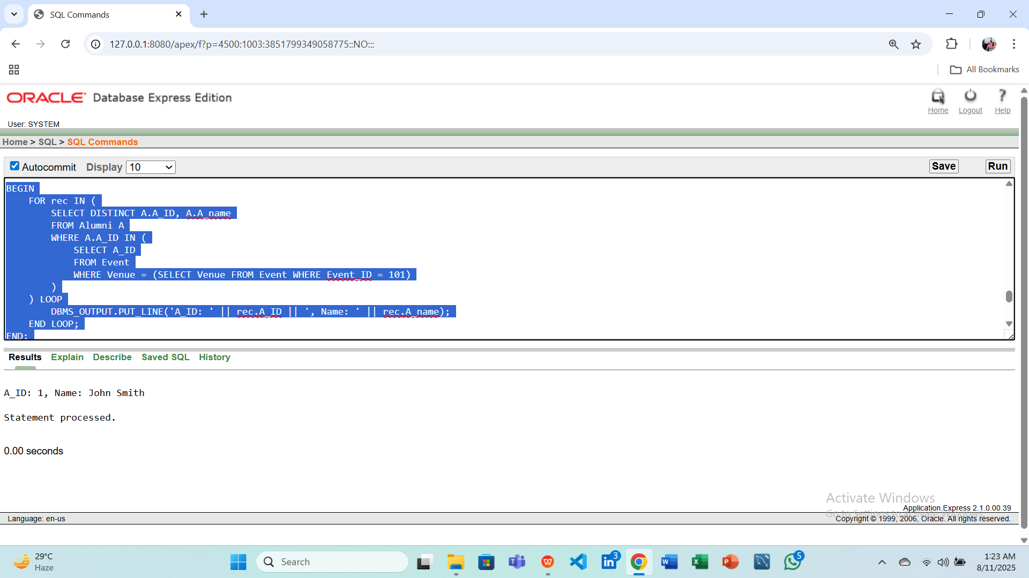

**4. Joins**

**Question(1): Display all alumni names along with the event names they are associated with.  
Answer:**

BEGIN

FOR rec IN (

SELECT A.A_name, E.E_Name

FROM Alumni A

JOIN Event E ON A.A_ID = E.A_ID

) LOOP

DBMS_OUTPUT.PUT_LINE('Alumni: ' || rec.A_name || ', Event: ' || rec.E_Name);

END LOOP;

END;

/

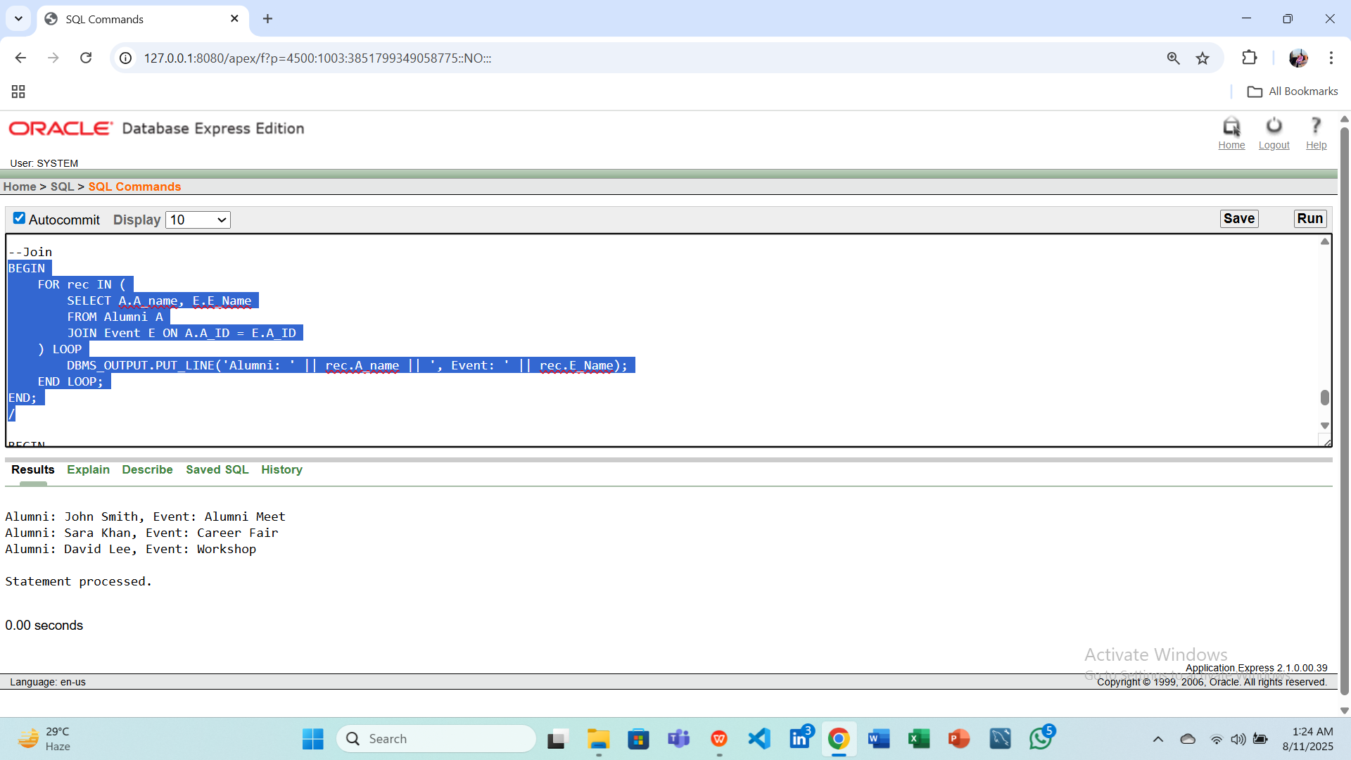

**Question(2): Display alumni names, event names, and session dates for all scheduled sessions.  
Answer:**

BEGIN

FOR rec IN (

SELECT A.A_name, E.E_Name, S.S_Date

FROM Alumni A

JOIN Event E ON A.A_ID = E.A_ID

JOIN Event_Session S ON E.Event_ID = S.EventID

) LOOP

DBMS_OUTPUT.PUT_LINE('Alumni: ' || rec.A_name || ', Event: ' || rec.E_Name || ', Date: ' || TO_CHAR(rec.S_Date, 'DD-MON-YYYY'));

END LOOP;

END;

/

